MEDICAL CHATBOT SYSTEM

This project is a healthcare chatbot designed to predict diseases based on user-provided symptoms. Utilizing machine learning algorithms such as Decision Tree and Support Vector Classifier (SVC), the chatbot interacts with users through text and voice to assist in diagnosing possible medical conditions with a high degree of accuracy. The chatbot also provides health-related precautions and descriptions for suggested conditions.

LANGUAGE : Machine Learning

TOOLS : ANACONDA NAVIGATOR
JUPYTER NOTEBOOK

Create a chatbot with the given dataset.

END TO END PROCESS:
- Pandas for data manipulation.
- scikit-learn for machine learning (Decision Tree and SVC).
- pyttsx3 for text-to-speech functionality.
- NumPy for numerical computations.
- CSV for reading and managing symptom data.
- Training Dataset: Contains multiple symptoms and the corresponding disease diagnosis.
- Testing Dataset: Used to evaluate the performance of the model.
- Symptom_Description.csv: Contains detailed descriptions for each disease.
- Symptom_severity.csv: Maps symptoms to their severity levels.
- Symptom_precaution.csv: Lists the precautions for each disease.
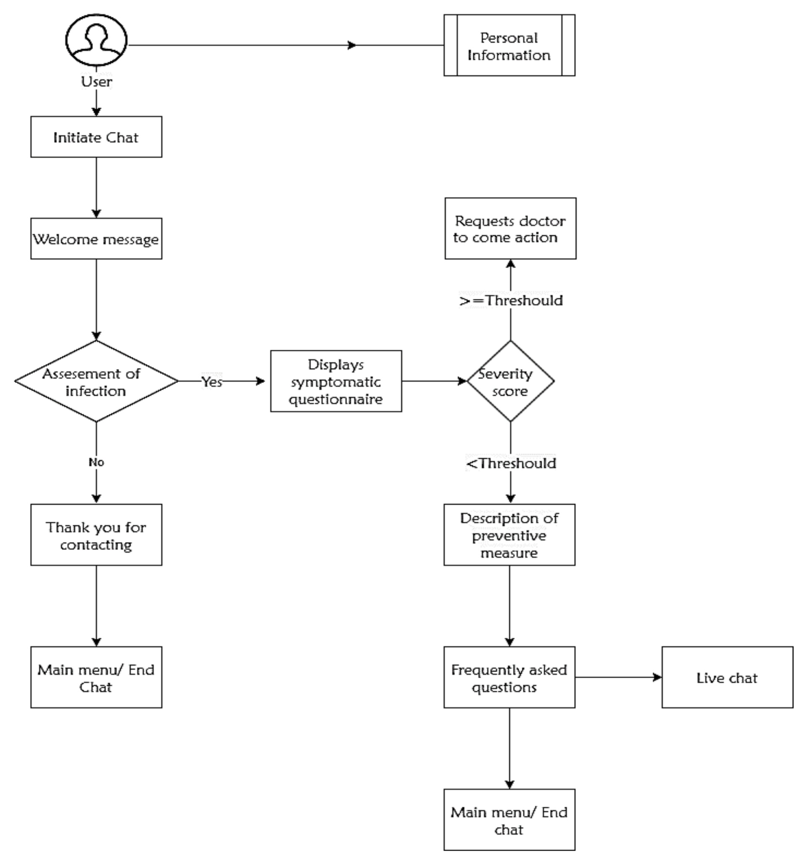

MODULES:
LOGIN / REGISTER
HOME
CHATBOT PAGE

